**Concrete action: Mammut makes climate contribution with revolutionary CO2 removal initiative**

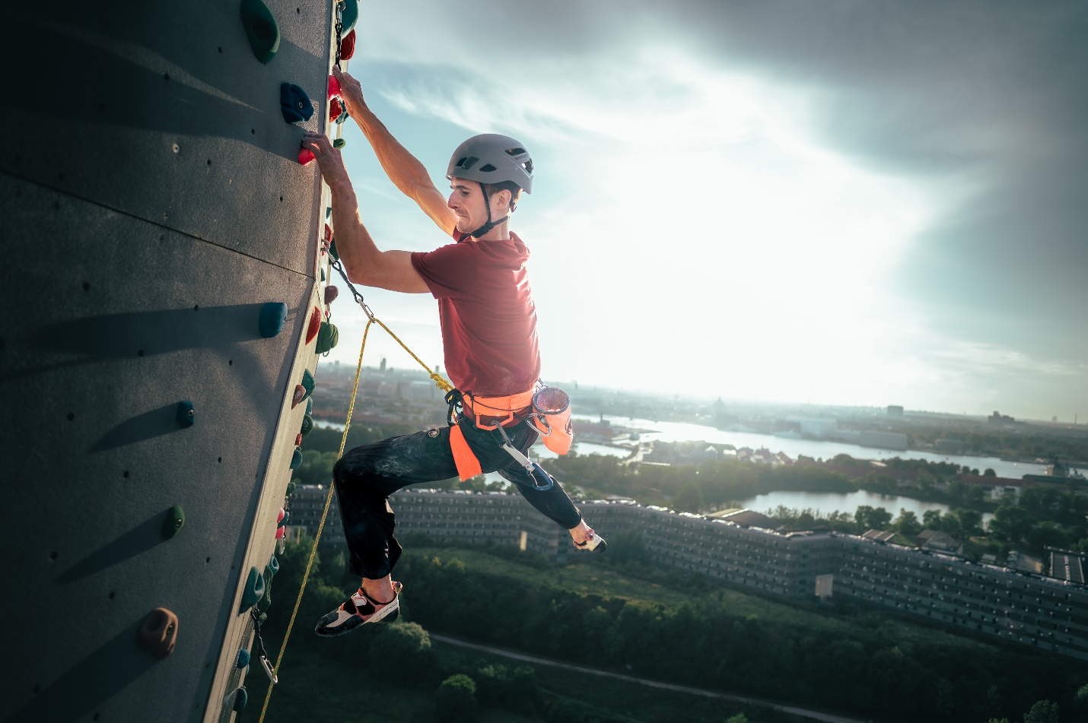

*Adam Ondra’s ascent on the exterior of CopenHill: a symbol of commitment to sustainability.   
©Petr Chodura / Mammut Sports Group AG*

Seon, Switzerland/Copenhagen, Denmark – **In a groundbreaking collaboration, Mammut, Klimate, ARC, Bofort, and Carbonaide have unveiled a cutting-edge project for carbon dioxide (CO2) removal and its storage in concrete, marking a significant step forward in the fight against climate change. The initiative is championed by none other than world-class climber Adam Ondra.**

As an outdoor sports company that relies on an intact nature, Mammut operates in a field of tension: enabling outdoor enthusiasts to have unique experiences in the mountains with durable equipment, while also protecting them from the elements and injuries. However, these products generate emissions throughout their production and travel to the mountains adds further emissions. The initiative developed from Mammut’s ambitious decarbonization strategy, “Do Our Best, Remove the Rest.” Mammut aims to halve its emissions by 2030 and reach net zero by 2050.

In addition to the significant reduction efforts being implemented at Mammut and throughout its supply chain (a 13% reduction in CO2 emissions from 2022 to 2023), the company is also exploring innovative ways to remove the remaining carbon emissions from the atmosphere.

**From gas to concrete**

The Danish tech start-up Klimate serves as the linchpin in this alliance, uniting all stakeholders toward a common goal: ARC in Copenhagen captures up to 4 tons of CO2 daily directly from the flue gas of the waste-to-energy plant. Bofort provides the ISO tank for liquefied CO2 and manages its transport to Finland where Carbonaide integrates the captured CO2 into their more sustainable concrete production process, thus binding it permanently. Mammut, as the “buyer” in this project, commits to decarbonizing a total of 90 tons of CO2 by the end of 2025.

Despite the innovative removal and storage process, Mammut’s primary goal is to reduce its emissions. As **Tobias Steinegger, Head of Corporate Responsibility at Mammut**, states: “*Through this cooperation, we aim to achieve tangible results in carbon removal and inspire other companies to eliminate their residual emissions after**making significant efforts to reduce their carbon footprints.*”

**Mads Emil Dalsgaard, Co-CEO of Klimate** states: “*This facility is just the beginning, with this investment paving the way for future scaling and development. We're really proud at Klimate to have Mammut and Adam Ondra as supporters to help make this project a reality.”*

**Adam Ondra’s ascent: A symbol of commitment**

The initiative’s visual representation features multiple-time World Champion and Olympian Adam Ondra climbing the artificial route on the exterior of CopenHill, one of the tallest of its kind globally. This symbolic climb not only highlights the physical challenges overcome by athletes but also underscores the commitment to environmental stewardship within the sporting community. The professional rock climber compares reaching net-zero to a very difficult and complex climb: *“This could be seen as doing the first moves or grabbing a tiny intermediate hold. But the important thing is that we are moving in the right direction.”*

**A legacy of sustainability and performance**

Mammut, the Swiss outdoor company established in 1862, has long been at the forefront of providing high-quality products and experiences for mountain sports enthusiasts. With a legacy spanning over 160 years, Mammut stands for safety, performance, and sustainability, offering a comprehensive range of hard goods, footwear, and clothing. Employing approximately 850 people, Mammut Sports Group AG operates in around 40 countries.

**About the partners**

* [**ARC**](https://a-r-c.dk/om-arc/) is a widely celebrated waste-to-energy plant in Copenhagen, Denmark, featuring the world’s tallest artificial climbing wall and a ski slope under the name of **CopenHill**, exemplifying modern urban development. The climbing wall of this urban mountain is run by the Danish climbing association Dansk Klattreforbund.
* [**Bofort**](https://www.bofort.com) is an independent cryogenic ISO tank leasing company located in Antwerp, Belgium which is dedicated to making carbon capture utilization and storage (CCUS) possible today by engaging its expertise and network in the global CO2 value chain, providing ISO tanks for the safe and reliable transport of liquid CO2.
* [**Carbonaide**'s](https://carbonaide.com/) award-winning carbon-curing technology, originating from VTT, the Technical Research Centre of Finland, can mineralize approximately 100kg CO₂ per cubic meter of concrete during the concrete production process. The technology does not only permanently store CO₂ but also contributes to the decarbonisation of the concrete industry by replacing cement - responsible for 90% of concrete’s footprint.

--> [Mediakit](https://drive.google.com/drive/folders/1ITwL-YYclYA4jtoAZ6q-3GRHrTZPaLBk)

* [**Klimate**](https://www.klimate.co/) is a climate tech start-up from Denmark committed to investing in and providing access to high-quality, innovative, verifiable carbon removal solutions, empowering businesses to achieve net-zero emissions. Guided by the latest science, they leverage tech to scale critical solutions that make a tangible impact in the fight against climate change.   
  --> [Mediakit](https://drive.google.com/drive/folders/1CLTcXZbXlJIdmb99d8yh5xYGXi6EmPvS)

This partnership reflects a shared vision for a sustainable future and a proactive approach to environmental responsibility. The collaboration is not just a statement but a tangible action against the climate crisis we are facing.

--> Link to Adam Ondra video on Mammut YouTube: <https://youtu.be/hIW05-D0i48>

--> Link to Mammut CR-Report 2023: <https://www.mammut.com/ch/de/support/sustainability>

**About Mammut**

Mammut is a Swiss outdoor company founded in 1862 that offers mountain sports enthusiasts worldwide high-quality products and unique brand experiences. For 160 years, the world's leading mountain sports brand has stood for safety and pioneering innovation. Mammut products combine functionality and performance with contemporary design. With its combination of hard goods, footwear, and clothing, Mammut is one of the complete suppliers in the outdoor market. Mammut Sports Group AG is active in around 40 countries and employs approx. 850 people.

**mammut.com**